Reply form CINET Growth Hacker Award 2024

This award is focused on market growth for the professional textile care industry by taking market share from the domestic laundry segment. This is visualized in the below figure.
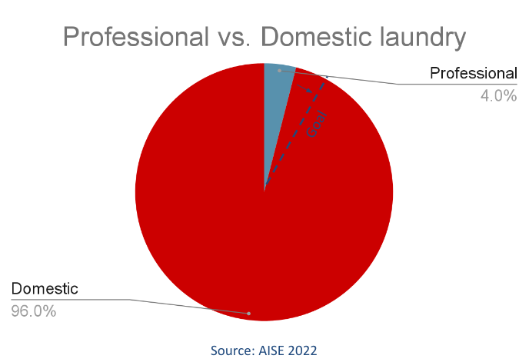
In this reply form you can showcase how your business is pushing industry growth. With this award CINET has the objective to stimulate PTC companies to service customer groups which weren’t serviced before, resulting in industry growth. This award is connected to the Global Best Practice Awards program. It will provide a benchmark and platform for the new state of the art in textile care.
The deadline for the reply form is September 10th, 2024.
The award will be presented in Frankfurt (8-9 November 2024). Nominees are invited and will be special guests of CINET on this event.

General company information
Name company
Contact person
Address
Country
Phone number
email address

Questionnaire
In this reply form the Business Model Canvas tool is used as the central methodology to evaluate the application. This is a strategic management template used to develop business models and visually document them. The jury will evaluate the application based on qualitative aspects (50 points) and quantitative aspects (50 points). Qualitative aspects are coherency of the business model, likelihood for success, innovativeness & scalability. Quantitative aspects are based on KPI’s (key performance indicators) such as sales/revenue (increase), #orders (increase), #customers (increase), retention rates, CAC (cost per acquired customer), CLV (customer lifetime value), ATV (average transaction value and Customer satisfaction scores.
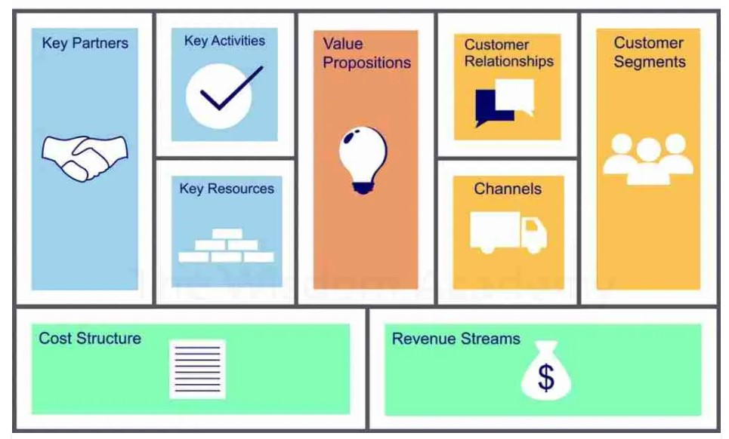
Plan vs. execution
In this award evaluation the jury will evaluate what your business is actually doing better than what you are planning. After all, a plan without execution is worthless. Nevertheless, please feel invited to share results as well as next step plans for your business as it will provide a good understanding about your entrepreneurial skills.
This model will be explained and discussed at the first ONLINE meeting March 23rd.
Participation in this GHA Program is open for persons / organizations in professional textile care, who want to set up new fresh initiatives for new business with a high potential for new customers and/or new services.

- Value proposition
What core value(s) do you deliver to your customer? Which customer needs are you satisfying? What problem are you solving? How is your proposition different from your competitors? What is the measurable impact of your value proposition?

- Key activities
What do you do? Which activities does your company undertake to deliver the value proposition? How many pieces / KG’s are you processing?

Key resources
What key resources does your value proposition require? What resources are most important for your distribution channels, customer relationships, revenue streams, etc.? For example how many machines, vehicles, people, etc. you use in your business model?

Key partners
Who are your key partners/suppliers? What are the motivations for the partnerships? For example how machine, detergent, transport, etc. partners?

Customer segments
What core customer segment(s) are you aiming to serve? What kind of market are they in? Focus on your most important customer profiles. For each segment indicate numbers of customers / customer growth percentages, the ATV (average transaction values) & items per order and the number of orders / order growth over time.

Customer relationship
How do you interact with customers? What communication channels are used, what is your tone of voice and how does it relate to your cost? What are your customer satisfaction scores (e.g. Google rating)? How often do customers use your service and what are the retention rates?

Channels
How do you reach customers? What communication & distribution channels are used? Which are most effective and how do they relate to your cost? (How can your channels be integrated into your customers habits? Think about direct (e.g. store-front) and indirect (e.g. 3rd party webshop) channels and the cost vs. the revenue of each channel. You can use CAC (cost per acquired customer) vs. CLV (customer lifetime value) data to strengthen your case here.

Cost structure
What does your cost structure look like? What is variable vs. fixed cost? How have you improved cost effectiveness over time, for example by creating economies of scale? Is your business model more focused on delivering value or minimizing costs?

Revenue streams
List all the ways your business is generating revenue. How is the revenue / sales distributed over the channels & services your business offers? Is it one-time, transaction based revenue or (monthly) recurring revenue? Perhaps your business has revenue sharing arrangements with key partners as well? Please also indicate how the revenue developed over time.

Pictures and photos
Please provide pictures and photos of your company and the key aspects of the business model. The goal of the pictures is to explain and clarify the answers. Any pictures that justify the award will be taken into account.

Procedure & Arrangement
CINET will organize 3 - 4 ONLINE meetings to inform potential applicants on this project, exchange ideas between participants on modern profession textile care and support participants upon request. This includes physical/online meeting 3rd week of august of 1,5 day at the ELECTROLUX Professional premises in Sweden. Furthermore, participants will be asked for a confirmation to participate after the First Meeting March 23rd and will be asked for a payment of 100 Euro, after April 1st 150 Euro application fee. This will include 2 Months FREE Access to the CINET Retail/Industrial Excellence E-Learning Modules as well as the CINET WOPCOM Platform 24/7 for independent PTC information, reports and studies.
The applications from participants worldwide will be evaluated by an International Independent Jury of esteemed professionals, chaired by Mr. Geert Boettger of EXPO+Consulting.

A max of six applications will be presenting a Pitch of 3 Minutes at the Global Awards Ceremony November 9, 2024, at the TEXCARE International show in Frankfurt, Germany where the Winner will be announced and rewarded.

The 20.000 Euro Reward will be made available as an investment for realizing the application applied and presented, conditionally to a further arrangement to spend the money and report one year later on a next CINET event (online) on the results.

CINET will be entitled to use the presented Pitches for further PR and publications. The applications itself will be made available to the jury members on the basis of a confidentiality agreement and only disclosed upon a written consent by the applicant for the period of 2 years.

CINET
CINET, the international committee of Professional Textile Care is the global umbrella association; as a platform for national associations, franchise companies, international suppliers and research institutes. CINET participates and coordinates in international research projects and organizes conferences and workshops to stimulate the exchange of information to accelerate innovation.

Reply
The reply form, as well as all documents, pictures, etc. can be sent to the CINET secretariat ultimately September 10th, 2024.

CINET Secretariat,
Molenstraat 29, NL-4061 AB Ophemert NL
Phone; +31 344 650 430
Email: cinet@cinet-online.com

